

Remember to wash your hands, cough into your elbow (mini ‘dab’) and try not to touch your face 😊. Stay healthy and safe.

Year 5

Home Learning Timetable

Due Friday 13th March 2020 Name: _________

|  |  |  |  |  |
| --- | --- | --- | --- | --- |
| **Week Commencing – 20th April** | | | | |
| **Task** | **Tuesday** | **Wednesday** | **Thursday** | **Friday** |
| **English** | SPaG and Comphension – See Purple Mash  Watch the youtube the magic box by Kit Write <https://www.youtube.com/watch?v=ReP3gVrOfpI>  Draw a box – what will you put in your box?  **write a sentence for describing one of your items  *** use alliteration and senses to describe some of your items | SPaG and Comphension – See Purple Mash  Twinkl magic box  <https://www.twinkl.co.uk/resource/t2-e-1005-recognise-some-different-forms-of-poetry-free-verse-lesson-teaching-pack>  Look at the poem can you identify  Alliteration  Onomatopoeia  **Repetition  ***Use of senses  Go through Power point from above pack | SPaG and Comphrension – See Purple Mash  Draft your own magic box poem, each verse to start with…..  In my box I will put…  followed by 3 lines of description.  Remember to include features discussed yesterday  *include Alliteration (3 verses)  **use repetition (4 verses)  ***include power of 3 (5 verses) | SPaG and Comphension – See Purple Mash  Write up your poem in best, add a boarder and pictures (which relate to your poem) |
| **Maths** | WARM UP –    See Mathletics for set work  See purple mash for warm up task  This weeks topic – shape  Watch and complete activities  <https://www.bbc.co.uk/bitesize/topics/zvmxsbk/articles/z98n4qt> | WARM UP- write as moany Roman numerals you can in 1 min.  See Mathletics for set work  See purple mash for warm up task  Watch and complete activities  <https://www.bbc.co.uk/bitesize/topics/zt7xk2p/articles/z247tv4> | WARM UP- Complete the follwing calcualtions: 98 x10 = , 0.98 x 100, 9.8 ÷10, 0.098 ÷100  See Mathletics for set work  See purple mash for warm up task  Watch <https://www.mathantics.com/lesson/polygons> | WARM UP- Complete the follwing calcualtions: 98 x10 = , 0.98 x 100, 9.8 ÷10, 0.098 ÷100  A screenshot of a cell phone  Description automatically generated  See mathletics for set work  See purple mash for warm up task  Watch  <https://www.youtube.com/watch?v=P3AOoLbA3us> |
| **Topic** | **RE — Hinduism**  Watch Watch and complete activities:  <https://www.bbc.co.uk/bitesize/topics/zh86n39/articles/zmpp92p> | **Art — Cityscapes**  Look at some examples of cityscape art online. Some artists might include Monet, Van Gogh, Paul Kenton, Wilfred Lang and Charles Fazzino.  Choose one and write a paragraph about what can you see. What techniques have been used? What shapes and lines can you see? | **Science - Scientists and Inventors**  Watch various different video clips about David Attenborough below:  Depending on time and preferences, you can watch more than one clip about David and his documentaries on: <https://www.bbc.co.uk/programmes/p03r3wqn>  BBC also honours David Attenborough through a series called ‘Five of Attenborough’s greatest moments’.  ▪ Giraffes in epic battle: from Africa (5 minutes)  ▪ Polar bear versus walrus: from planet Earth (4.29 min)  ▪ Criminal penguins steal stone: from frozen planet (1.53 min)  ▪ Jesus Christ lizard runs on water: from life (2.29 min)  ▪ Sugar glider’s stunning flight, from life on earth (1.14 min)  Activities:  *reasearch and create poster boards, or fact sheets about a chosen animal.  ** write letters to David Attenborough about how he inspires them  *** Research Life of David Attenborough and create a fact file  a. Twinkl provides a ‘Mini Biography’ template if needed.  b. This can be supported with an additional powerpoint titled ‘The Life of David Attenborough’ which goes into greater detail about David Attenborough and his upbringing etc. this can be used to support the fact file and or mini biography. | **History - Who were the Ancient Egyptians?**  Ask your child to imagine that they are Egyptologists and their first job is to study a picture below (on page 4) that was found in a real Ancient Egyptian tomb.  Fill in grid alongside picture after you have talked about it.  Write down any questions or puzzles generated by looking at the picture.  Locate Egypt on google maps. Find a map of Anciet Egypt online and compare the two maps. What is the same? What is different?  Watch the video clip about who the ancient egyptians were:  <https://www.youtube.com/watch?v=tqY-_wAH4Wg&vl=en>  Then order the cards on page 5 in chronological roder to create your own timeline.  *ask an adult to help you do this  ** complete independently  *** complete indpendently and create an extra date card to put into your timeline based on some research you carried out. |

**Everyday activities:**

**Exercise**

**Complete your favourite online exercise program or go for a walk.**

**Relax**

**Find your favourite way to relax.**

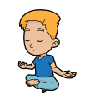

**Talk Time**

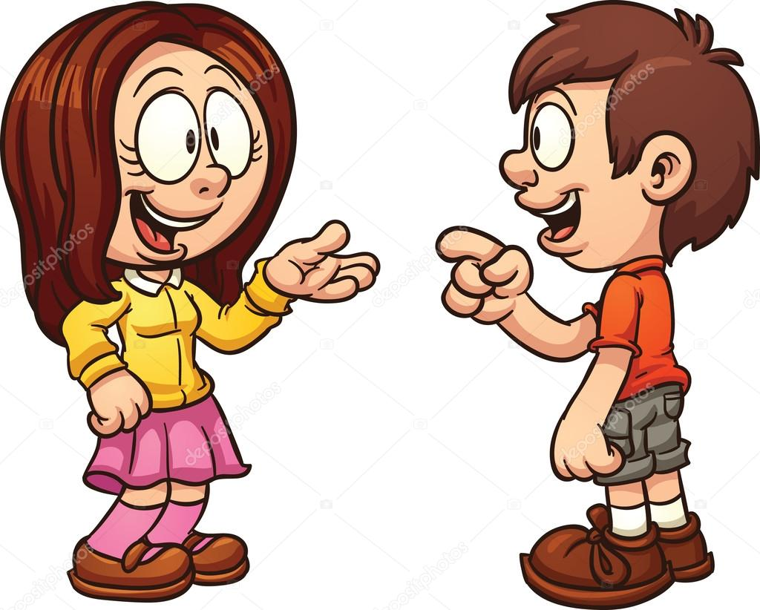

**Talk about how you are feeling or questions you may want to find out the answer to.**

**Story time**



**Read for 20 mins each day**

Fun Family Challenges:

Help with the household chores

Play a board game

Invent a new game with a parent/carer or sibling

involving a ball and scoring system

