Nursery Home Learning Ideas and Website Links
Phonics/Writing/Reading:
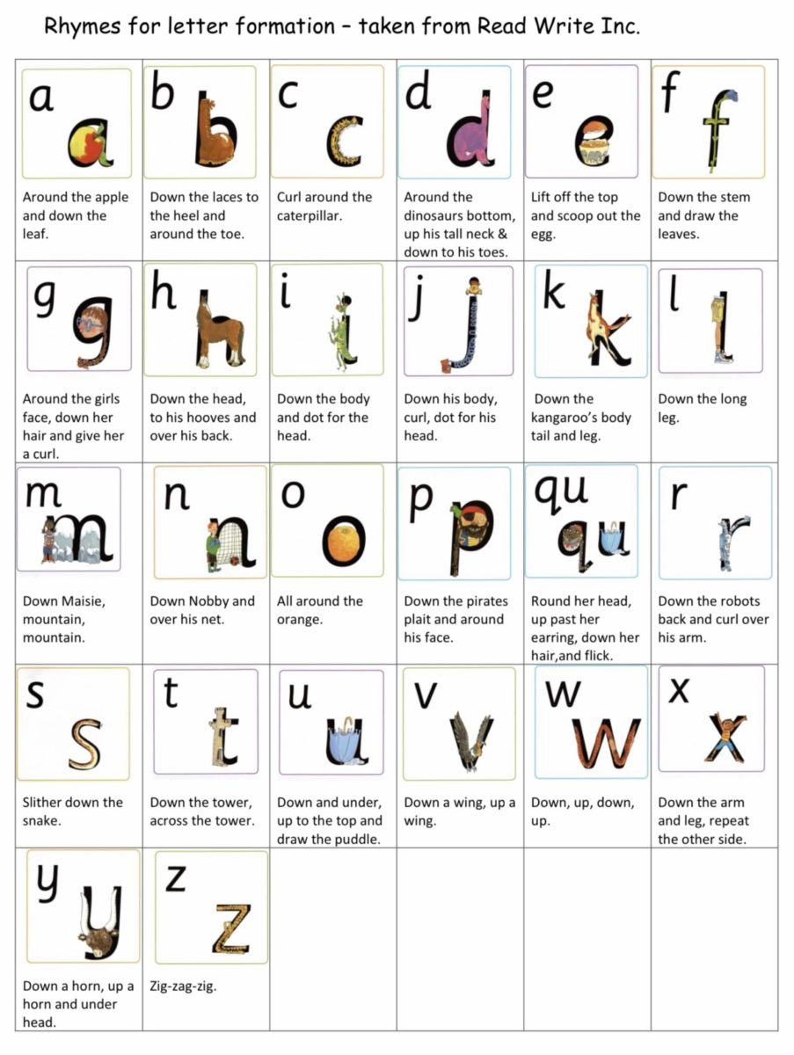
- We follow the Read Write Inc Phonic approach. Here are a list of the letters and how they are formed with a rhyme that goes along with the letter to help remind children how to write the letter.

- You could ask children to try and practice writing their names, initial letter of their name or trace their names if they are unable to form the letters correctly.
- Your children could help you write a shopping list if you go out to do your shopping.
- Try and read as many books with your children as you possibly can to help develop their vocabulary and love of books. If libraries are open you could use these to get a wide range of books to use.
- You could sing phonics songs on YouTube such as “A is for apple” which the children at nursery know very well. Here is the link: https://www.youtube.com/watch?v=jPVbJ-IaHIw

Maths:
- Nursery rhymes/counting rhymes are great for aiding counting.
- Using music/songs on YouTube is a great way of encouraging number recognition. Try “Let’s Count up to 10” which the children know well: https://www.youtube.com/watch?v=6RfIKqkvHTY
- If you are out for a walk count how many cars you can see and also the colour of them.
- Look for shapes in the environment both at home and outside.
- Get your children to help measure ingredients out while you cook.
Keeping Active/Physical Development:
- Get outside if and when you can – go for a walk to the park or around your local area.
- Scissor skills – practice cutting out shapes you have drawn.
- The children enjoy our Yoga sessions at Nursery. You can search “Cosmic Kids Yoga” on YouTube and the children follow the instructions on screen.
Expressive Art and Music:
- Do lots of messy activities such as painting, play-doh, plastercine.
- Role Play day to day activities/dressing up.
- Sing familiar songs with the children.

