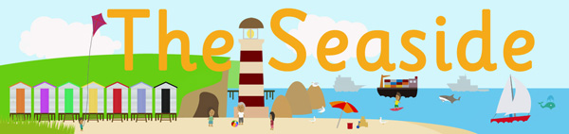

Dear Parents,
Our topic for this term is called: “At the Seaside!” At nursery we would have been learning all about boats, animals that live in and near the sea, stories set by the sea, mermaids, shells, lighthouses and holidays. At the end of the term we would have been dressing up for a ‘Hawaii Beach Party’ with mocktails, beach games and beach party music! If we are not back in nursery by the end of this half term then it would be lovely if you could all have your own beach party at home and share the photos!
Here is a list of some of the activities we would have been completing in nursery during this half term. It would be wonderful if you could complete some of these activities at home and share the photos! Also if you have other activity ideas you would like to do with your child on the seaside theme then we would love to see them!

Reading:
- Read both Non-Fiction and Fiction books about the sea such as ‘The Lighthouse Keepers Lunch’, ‘Commotion in the Ocean’ or ‘The Rainbow Fish’. You Tube has a good collection of stories if you don’t have the physical books available.
- Look at holiday brochures (online if you don’t have physical copies) or holiday magazines.
Writing/Mark Making: (Templates for some of these activities will be shared soon)
- Write a postcard from a pretend or real holiday trip.
- Write a mocktail recipe ingredient list.
- Make a list of things to pack in your suitcase.
Maths:
- Make a pretend ice cream parlour with real ice cream and count the scoops!
- Counting shells and pebbles.
- If you have sand at home try and find big and small buckets for children to fill and make sandcastles and compare the sizes.
- Try and make a beach huts using 2D Shapes or items to draw around that you can find in the house.
Expressive Arts:
- Sing songs about the sea such as sea shanties or eve Baby Shark! (Lots of songs can be found on You Tube)
- Make a colourful glittery Rainbow Fish.
- Make a jelly fish using yogurt pots and strips of paper for tentacles.
- Make a lighthouse using a fizzy drink bottle.
- Mix sand with paint to make some lovely textured paint.
- Make seaside pictures by drizzling glue onto the page and then sprinkling with sand.
- Roll out some large paper, such as backing paper, on the floor or attach to a fence or wall. Give your child blue and yellow paints to create their own seaside scene.
- Play some relaxing ‘waves’ sounds for your child to calmly move to.
- Listen to different sounds from the seaside (you may be able to find these online), such as gulls, the waves, the wind, children laughing. Your child can listen to the sounds and try to name them.
Understanding the World:
- Fill the bath, paddling pool or a bowl of water and see which objects float and sink.
- Explore the clothes that should be worn during a summer trip to the seaside. Make a pile of summer and winter clothing. Can your child sort the clothes into two groups?

We hope that gives you some nice ideas to help your child at home while we are away. We would love to see the work they produce so please share all your efforts via Class Dojo. We will be giving out Dojo points to the children as well for their work. If you have any queries then please feel free to message me through the Class Dojo App.

Hope to see you all soon!
Mr Ammon

