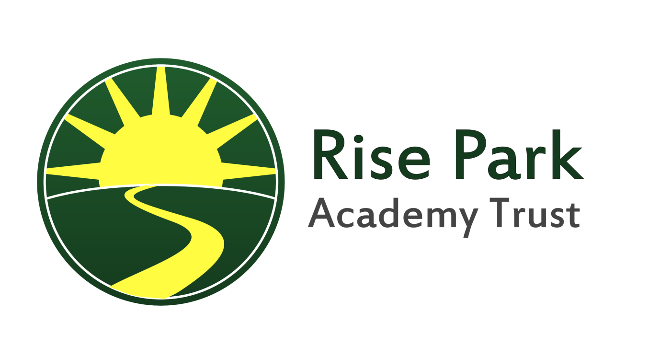
COMMUNICATIONS POLICY
At Rise Park, we believe that good communication between school and the home is essential. Children achieve more when schools and parents work together. Parents can help more if they know what the school is trying to achieve, and how they can help.
In our school we aim to have clear and effective communications with parents and the wider community. Effective communications enable us to share our aims and values through keeping parents well informed about school life. This reinforces the importance of the role that parents play in supporting the school in educating their children.
These are our principles:
• Communicating with stakeholders, particularly parents, is a core part of what we do, not an afterthought.
• We will always share as much information as possible about any issue.
• If we cannot share information we will explain why.
• We will work as transparently as possible by offering clear explanations for major decisions.
• We will communicate in a timely fashion and try to avoid parents receiving information about the school from other sources first.
• We will communicate in a voice which is courteous and jargon free
• Where information relating to the school is available in the public domain, we will direct people to it.
• We acknowledge that some information is of a confidential nature and will always respect that confidentiality.
• We will communicate with all school stakeholders
Strategies
We communicate with parents through a range of different strategies. Some of our communications are the result of a statutory requirement; others reflect what we believe is important to our school:
Talking with staff
Class teachers are always available for a ‘quick word’ at the end of the day. However, if you need to talk with the class teacher in more detail, please make an appointment for a telephone conversation or a meeting in person, as talking at length in the playground after school is difficult for the teacher and the children.
A member of the Leadership Team will always be on each gate at the start of the day. Many parental queries and concerns can be dealt with at this time. It is also possible to make appointments through the school office.

Meetings
There are a number of meetings through the term which provide opportunities to discuss current developments in the school:
- New parents - we hold a new intake meeting for new reception parents each June. The Infant School also organises a morning meeting for new parents at the start of the Autumn term which is an opportunity for parents to meet each other and members of the school Leadership team, as well as representatives of the school PTFA, school nurse, attendance officer etc.
- Transition Visits - the Early Years team make pre-school visits in the summer term for, reception pupils, to share information with the main feeder providers and to complete on-entry records which contain information about the child.
- We have curriculum meetings in September for children in Years 1 and 2 to discuss their literacy, numeracy and topic work for that year. We have a Year 6 meeting to discuss end of year tests/tasks in October. We hold secondary school transition meetings during Year 6.
- Year 6 visit and other residential trips – where a major trip is taking place, such as the year 6 residential trip, the visit leaders will organise a meeting for parents well in advance to provide detailed information about all aspects of the visit.
- Parent Workshops - these occur termly and will always have a specific focus, such as maths, literacy, phonics, spelling, punctuation and grammar etc.

Website
The school websites, http://www.riseparkinfants.co.uk and http://www.risepark-jun.havering.sch.uk are regularly updated with information about the school, including up to date policies, current news about what is happening in school and news of any changes to routine. The school calendar can also be found on the website and is regularly updated. Staff lists and responsibilities are also kept on the school website in the information section.
E Mail Communication
The school uses the Parentmail system as a method of e-mail communication. Parents are asked to register for this method of communication on admission to the school. If e-mail is chosen as the preferred method then newsletters, whole school and group letters will be sent electronically, wherever possible, replacing the paper copies. Hard copies are sent out to anyone who does not have Internet access. Letters are also translated into alternative languages, both in hard copy and on the website, if requested.
Use of Social Media
The schools do not currently have a Facebook/Twitter social media facility. All electronic communication from the schools to parents must be via Parentmail (including the Parentmail Parents’ Evening booking facility). No member of staff is permitted to befriend any current pupils on a social media site or to contact parents/communicate any information on behalf of the school to them. Contravention of this code of conduct, or any other form of communication which could bring the schools into disrepute, may lead to disciplinary action.
All pupil mobile phones are handed in to the office, and signed for, at the start of the school day, to be collected and signed out at the end of the school day. No pupil is allowed to use social media sites whilst at school. Any social media activity out of school cannot be deemed to be the schools’ responsibility unless it concerns a related school incident, which could be resolved by the parents in partnership with the school.
E safety sessions are offered on an annual basis to pupils, staff and parents, as part of the Trust’s safeguarding agenda. The community police also visit the Junior School to lead assemblies on topics such as cyber bullying, and stranger danger on the Internet.

Noticeboards
There are notice boards at the front entrance to the school which detail daily events and notices. In addition, there is a PTFA noticeboards in the main entrance, which is updated with details of meetings and other relevant information.

Parents evenings and school reports.
Parents are expected to show an interest in the schools’ teaching methods and in their child’s progress by attending Parents’ Evenings, workshops, open days and reading their child’s reports.
We do encourage parents to contact the school at any time if any issues arise regarding their child’s progress or well-being, but we also provide two formal opportunities to meet one to one with the class teacher during the academic year. The first meeting is midway through the Autumn term and identifies areas of strength and targets for future development. Parents are invited to meet with their child’s teacher again during the Spring term to review their child’s progress towards the targets. Parents are able to look at their child’s work during these meetings. Parents will be given information and advance notice about such events in the newsletter and on the website.
At the end of the Summer term children will receive an end of year written report and parents can subsequently arrange to meet with teachers if there are any concerns/look at their child’s work. In our school we ask the parents to comment on their children’s progress using the annual report response form. We also give parents/carers of children in Year 2 and Year 6 the details of their attendance record, their performance in the national tests, and details of national comparative performance.
Home School Agreement
Our current home-school agreement has been in place since September 2013. It is a requirement of the School Standards and Framework Act 1998. It explains the schools’ aims and values, the schools’ responsibilities towards the children, the responsibilities of parents, and what the school expects of the children. We ask parents to sign this agreement when their child starts in our school.
The agreement covers the standard of education in our school, the ethos of the school, our expectations of attendance and good behaviour, and our expectations of homework. Our governing bodies review the agreement annually.
Staff communication with parents
Copies of letters sent home are kept in the school office. Details for the protocol for communicating with parents and carers via text and e mail are provided in appendix 1.
At the beginning of each term all teachers will share a summary of their curriculum plans. This enables parents to support their child’s work through a range of suggested activities to be shared with the child at home. These are also made available on the schools’ websites. Wherever possible we also invite parents to take part in an educational visit that is linked to the work.
Children in all year groups Reception to Year 6 have a home/ school record which enables parents to record comments and class teachers to communicate achievements and targets in reading.

School brochure
A school brochure is available containing a range of information to give new and prospective parents a full picture of provision at our school. We update this document every year and add it to our website. An up-to-date copy will also always be accessible in the lobby area.
Public access documents
The school makes available a range of documentation for parents. We keep a master set in the headteacher’s office, and we make these available on request. It contains copies of all school curriculum policies, minutes of governing body meetings and copies of policies that the governing bodies are required to have in relation to charging and remissions, sex education, health and safety, curriculum, performance management, admissions and action planning following inspection. It also contains a range of national and LA documentation. A copying charge may be levied where requests for printed materials are made.
Conclusion
Good communication is vital to home-school partnership. The raising of standards cannot be achieved without such a partnership.
Adopted: March 2019
For review: March 2021

RISE PARK ACADEMY TRUST
APPENDIX 1
E MAIL and TEXT PROTOCOL for staff communication with parents
This is guidance on when to send an e mail or text from Rise Park Schools to parents/carers. It should be used in conjunction with the Communication and E-safety policies.
As a broad overview, e mails and texts should be used for communicating essential information only. Parents/carers may wish to e mail the school about their children but the school should only use e mail to set up a meeting, so that personal communication about individual children is discussed face to face, by phone or letter and only in the last instance, by e mail or text.
N.B. No communication from the school should be sent out without the permission of the Executive Headteacher.
E MAILS
Group e mail addresses can be collated under year group, club register, class group or whole school categories. Groups will be administered by Senior Leaders and the School Administrative Assistant, so that they can communicate information where only one group is affected (e.g. Y6 visit/trip information/secondary transfer meeting).
- Staff should not enter into discussion with parents/carers about children via e mail but should use it to make a face-to-face appointment or by referral to the office.
- Ad hoc information such as the cancellation of an after school club can be sent by text, email or phone only.
- Individual e mails/texts to parents/carers should not be sent by the office unless to make an appointment.
- All group/other e mails to parents must be viewed by a member of the LT before they are sent.
- With permission of the Headteacher, the PTFA may send a group e mail to all parents e.g. asking for help with a school fair, as well as sending out their own newsletter for information.
TEXTS
- Due to cost, texts e.g. Parentmail should only be used as a primary resource for informing parents/carers of a school closure (e.g. snow) or an emergency situation.
- In the event of sickness or an accident parents/carers should be telephoned, not sent a text. However, a text may be sent asking the parent/carer to contact the school.
- Texts must not be sent regarding behaviour of an individual child by a teacher or by the office. Contact should be face to face, by phone or letter.
- News of great significance must not be sent by text but should come by e mail/letter from the Headteacher.

