

Remember to wash your hands, cough into your elbow (mini ‘dab’) and try not to touch your face 😊. Stay healthy and safe.

Year 3

Home Learning Timetable

Due Friday 13th March 2020 Name: _________

|  |  |  |  |  |
| --- | --- | --- | --- | --- |
| **Week Commencing – 20th April** | | | | |
| **Task** | **Tuesday** | **Wednesday** | **Thursday** | **Friday** |
| **English** | **Spelling focus** – Words ending in – ***ary***  - library - boundary  - february - salary  - dictionary - summary  **SPAG Focus** – Alliteration  We know that alliteration is when the first letter is the same in multiple words. For example, **sad spider/tired tiger**.  Make a list of 20 animals. After you have done this, add alliteration in front of each animal, exactly like the sad spider and tired tiger above.  Can you add an action afterwards which also uses alliteration? For example, **The sad spider spins a sparkly silver web.** | Listen to chapter 1 of the iron man by Ted hughes. <https://www.youtube.com/watch?v=ycgfA-7udHs>  Listen carefully to the introduction and list all of the adjectives used to describe the Iron man.  Draw a picture of what you think the Iron man would look like. Around the drawing, write your own adjectives to describe him. Can you extend your writing and include a simile or alliteration? | Read “The coming of the iron man” poem by Brenda Williams  <http://brendawilliamspoet.co.uk/Ironman.html>  How many poetry tools can you find in the text? Is there any rhyme or repetition? Make a list of all the tools you find.  Try to rewrite the first two stanzas of the poem. You could change just the adjectives or the whole thing. Think about making a rhyming bank before writing, to help you think of ideas and plan your writing. | Have another look at “The coming of the iron man” poem.  Think about how this poem might be performed. What actions could be added to each line? Would your ecpression change for some words?  Perform the poem in front of your family, remember how expressive poets like Michael Rosen are when they perform. |
| **Maths** | Count in 5s forwards and backwards to 100 Telling the time: re-cap  <https://www.youtube.com/watch?v=NS-2dUpkoHA>  See **Purple Mash** for tasks set for today. | Count in 5s forwards and backwards to 200  Telling the time: analgoue to digital  <https://www.youtube.com/watch?v=h6RNkQ7lU8Y>  See **Purple Mash** for tasks set for today. | Count in 5s forwards and backwards to 500  Telling the time: analgoue to digital  <https://www.bbc.co.uk/bitesize/topics/zkfycdm/articles/zcrmqty>  See **Purple Mash** for tasks set for today. | Count in 5s forwards and backwards to 1000  Telling the time: Roman Numerals  <https://www.bing.com/videos/search?q=Roman+Numerals+Song&&view=detail&mid=8B529DFC2164F114A7858B529DFC2164F114A785&&FORM=VRDGAR&ru=%2Fvideos%2Fsearch%3Fq%3DRoman%2BNumerals%2BSong%26FORM%3DVDMHRS>  See **Purple Mash** for tasks set for today.  See **Mathletics** tasks that have been set for this week. |
| **Topic** | History- Romans  What do you know about the Roman empire? Can you name any key people from the time?  Read through informational sheet by copying the link below:  <http://www.primaryresources.co.uk/history/docs/romans_generalinfor.doc>  Create a timeline outlining the events from the information sheet. | PSHE- Rules  Create an informational poster listing 10 rules that you need to follow at home.  Challenge: write down why it is important to follow rules in society. | Science- Magnets  What is a force? Focus on push and pull. Write down 3 examples of when you use pulling/pushing forces.  Think of an action that shows how forces move objects. Create a freeze frame of the action you have chosen. Show your freeze frames to someone at home. Can they decide if you are demonstartying a pushing or pulling force? | RE- Places of Worship  Watch the following clip on churches: <https://www.bbc.co.uk/bitesize/clips/zkvcd2p>  The clip introduces some of the main features of a Catholic Church. A tapestry explaining the importance of Mary to the Catholic Church is featured, and there is a look at stained glass windows and statues of some of the saints.  Create an informational leaflet describing some of the features in a church, explain what the purpose of a church is. Make it colourful and eye-catching! |

**Everyday activities:**

**Art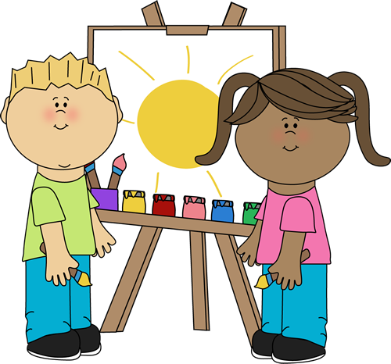Create a piece using resources of your choice!**

**Relax**

**Find your favourite way to relax.**



**Story time**



**Share a book at least once a day.**

**Exercise**

**Complete your favourite online exercise program or go for a walk.**

Fun Family Challenges:

Create a musical instrument

A housebound treasure hunt

Rock painting

Tie your shoelaces