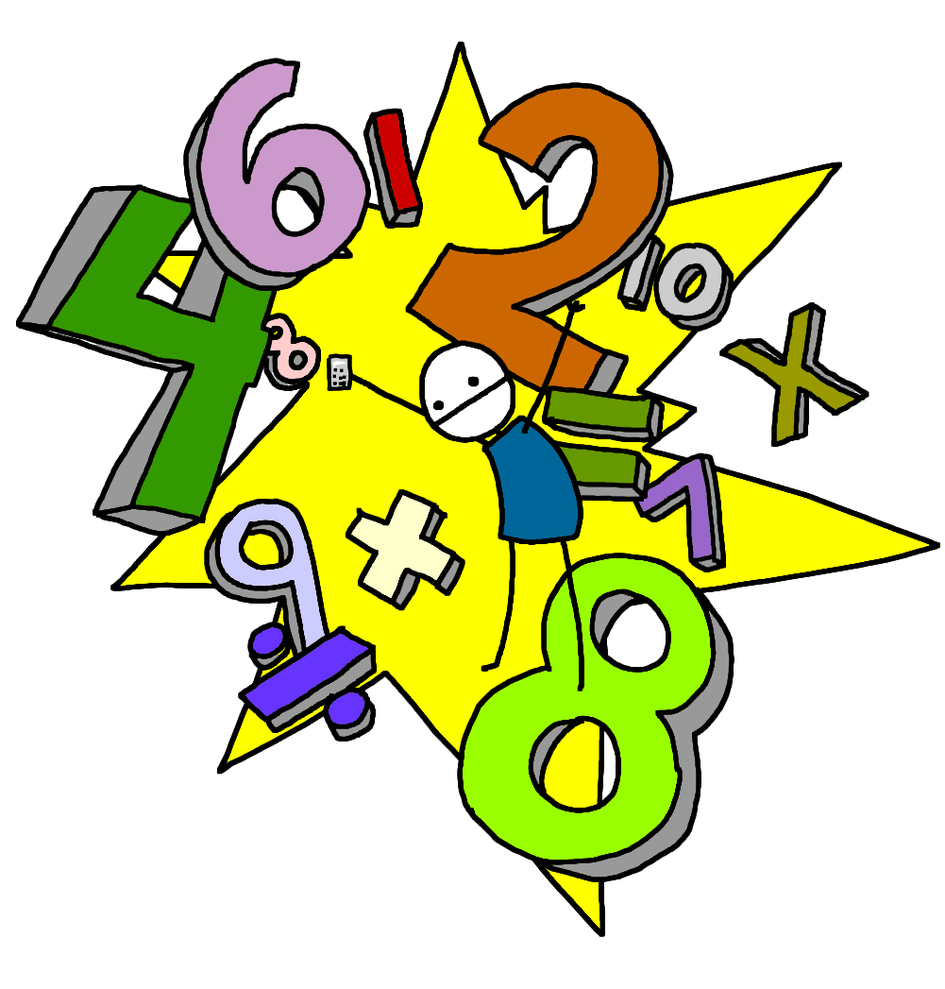
Home Learning Pack
Name: _________

Mrs Nortje’s Maths Set
Homework due on Friday 12th January 2018

Dear Year 2
In addition to the maths booklet and reading comprehension tasks please remember that you can log on to your espresso account where you can complete maths, English, computing, science and a range of other topic activities. Log on to: www.discoveryeducation.co.uk Username: student12191 Password: Unicorn
Please also find attached some English and Maths home learning packs for children to complete from classroomsecrets.com. You may also set up a free twinkl account who are offering a free subscription for parents so that you can download and access lots of year 2 resources and activities. www.twinkl.co.uk/offer using the password: UKTWINKLHELPS
To read interactive colour code stories please join and sign up (for free) to www.oxfordowl.co.uk where you can read colour code ebooks – listen to audio and then play a comprehension / grammar game at the end of the story
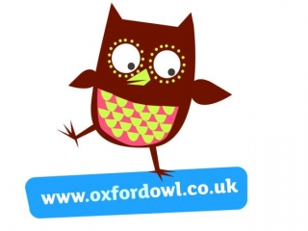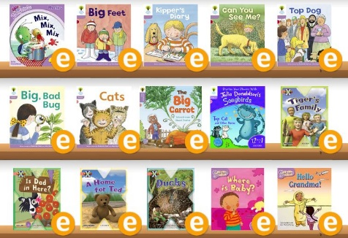
Use www.phonicsplay.co.uk who are offering a free one month subscription. Username: march20 Password: home
Below is a list of other free educational websites for children to use:
- PBS Kids
- Make Me Genius
- National Geographic Kids
- topmarks.com
- Funbrain
- Storyline Online
- The Happy Scientist
Why not complete one of the following activities:
Spelling Activities Year 2
Find the Letters  Cut out the letters from a newspaper/magazine to spell the words | Word Search  Create your own word search using the spellings | Bubble Writing  Write out your spellings in bubble writing-colour and decorate
Word Detective  Investigate to find other words with the same spelling pattern-how many can you find? | Hidden Answer  Write questions with the spelling as the answer. Cover up the answer with paper (as a flap). Did your friend guess the answer correctly? | Rainbow Words  Write the spellings in different colours

Reading Activities Year 2
Write a list  (such as a list of objects the character might pack in their holiday bag ) | Draw the character and label what they are wearing/what they look like | Draw your own comic strip
Draw a map of where the character lives | Write a set of instructions  (such as making a cake if there was a cake in the book) | Draw/make an item from the book

Remember to revise your 2, 3, 5, 10 x tables. For those who are learning their 4 x tables – keep going! Read every day and remember to include some active time. Follow the cosmic yoga videos on youtube or the just dance for kids videos.
Stay healthy and stay safe. See you all soon!
Mrs Nortje and the Year 2 Team.

